
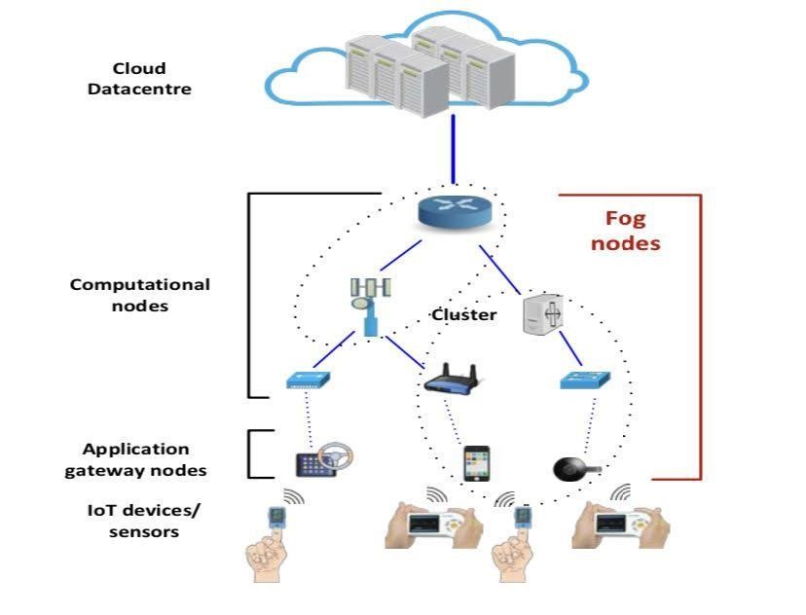
Jawahar Education Society’s

A.C. Patil College of Engineering, Kharghar

Experiment No. 9

Title
:

Case Study on Healthcare in IoT using ifogsimulator

Aim:

Theory:

In Healthcare solution, hand held or body connected IoT devices for example; pulse
oximeter, ECG monitor, smart watches, etc. perceive health context of the users through a Client
application module. The IoT devices are usually connected with smart phones.

The smart phones
act as the Application gateway node for the corresponding application. These nodes pre
-
process
the IoT
-
device sensed data. If resource availability in Application gateway node meets the
requirements, the data analysis and event ma
nagement operation of the application is conducted
there otherwise the operations are executed in upper level Fog computational nodes. For the second
case, Application gateway nodes select suitable computational nodes to deploy other application
modules an
d initiates actuators based on the result coming from those modules. Extending such
case of IoT
-
enabled healthcare solution, we discuss the way to simulate the corresponding Fog
environment in iFogSim. The system architecture and application model for the
IoT enabled
healthcare solutions is represented in Figure 1 and 2 respectively. Features of the system and the
application along with required guidelines to model them in iFogSim are listed below:

Fig.1
Fog environment for IoT
-
enabled healthcare

It is an n
-
tire hierarchical Fog environment. As the rank of Fog levels goes higher, the number of
Fog devices residing that level gets lower. Fog devices form Cluster among themselves and can be
mobile. IoT devices (pulse oximeter, ECG monitor, etc.) are connected t
o lower level Fog devices.
The sensing frequency of the IoT devices are different. Steps to model these physical entities are:

Semester: VII Department: CSE(IoT
-
CS BC) AY:2023
-
24

Jawahar Education Society’s

A.C. Patil College of Engineering, Kharghar

- Create FogDevice object and define n-tire hierarchical Fog environment by following Code Snippet 1 and 10.
- Create Sensor object with different sensing interval and transmission of a particular number of Tuples using Code Snippet 5 and 6.
- Model mobility of and form cluster of the Fog devices by modifying Code Snippet 7 and 9 respectively.
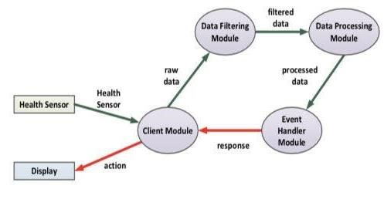
Fig.2 Application Model for IoT-enabled healthcare Procedure:
- All Steps are same which was covered in experiment number 5.
- Open the file as a Java application
3]An simulation window will open in the screen.
- Add three fog devices as Data Center, Upper Scheduler & Lower Scheduler.
- Add three sensors as Patients, Players and Data Sensors.
- Connect all the devices and sensors in order.
- Once you are done Click on the save button to save your file.
- Import your file from the saved location to check your simulation. <This message was edited>

Result:

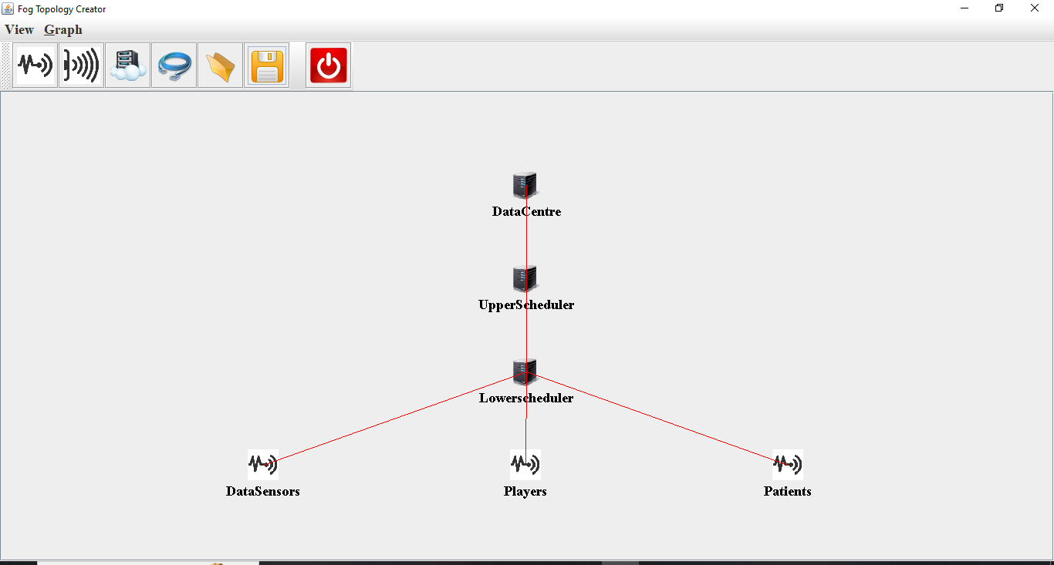

Conclusion:-
Hence we have successfully done Case Study on Healthcare in IoT using ifogsimulator.

